**SQL QUERIES**

CREATE SCHEMA `employeedatabase`;

CREATE TABLE `employeedatabase`.`employee` (

`Emp_ID` INT NOT NULL,

`Emp_Name` VARCHAR(45) NOT NULL,

`Emp_Age` INT NOT NULL,

`Emp_Dep` VARCHAR(45) NOT NULL,

`Dep_ID` INT NOT NULL,

`Emp_Location` VARCHAR(45) NOT NULL,

PRIMARY KEY (`Emp_ID`));

CREATE TABLE `employeedatabase`.`department` (

`Dep_No` INT NOT NULL,

`Dep_Name` VARCHAR(45) NOT NULL,

`Dep_Location` VARCHAR(45) NOT NULL,

`Project_ID` INT NOT NULL,

PRIMARY KEY (`Dep_No`));

CREATE TABLE `employeedatabase`.`project` (

`ID_Project` INT NOT NULL,

`Project_Name` VARCHAR(45) NOT NULL,

`Project_Location` VARCHAR(45) NOT NULL,

`Project_Strength` INT NOT NULL,

PRIMARY KEY (`ID_Project`));

CREATE TABLE `employeedatabase`.`dependent` (

`E_ID` INT NOT NULL,

`Dependent_Name` VARCHAR(45) NOT NULL,

`Dependent_Relation` VARCHAR(45) NOT NULL,

PRIMARY KEY (`E_ID`));

**EMPLOYEE TABLE**

ALTER TABLE `employeedatabase`.`employee`

ADD COLUMN `Emp_Salary` INT NOT NULL AFTER `Emp_Location`;

INSERT INTO `employeedatabase`.`employee` (`Emp_ID`, `Emp_Name`, `Emp_Age`, `Emp_Dep`, `Dep_ID`, `Emp_Location`, `Emp_Salary`) VALUES ('101', 'Ravi', '32', 'HR', '111', 'Banglore', '20000');

INSERT INTO `employeedatabase`.`employee` (`Emp_ID`, `Emp_Name`, `Emp_Age`, `Emp_Dep`, `Dep_ID`, `Emp_Location`, `Emp_Salary`) VALUES ('102', 'Ishitha', '25', 'Sales', '113', 'Chennai', '15000');

INSERT INTO `employeedatabase`.`employee` (`Emp_ID`, `Emp_Name`, `Emp_Age`, `Emp_Dep`, `Dep_ID`, `Emp_Location`, `Emp_Salary`) VALUES ('103', 'Rupa', '23', 'IT', '112', 'Hyderabad', '25000');

INSERT INTO `employeedatabase`.`employee` (`Emp_ID`, `Emp_Name`, `Emp_Age`, `Emp_Dep`, `Dep_ID`, `Emp_Location`, `Emp_Salary`) VALUES ('104', 'Kiran', '27', 'Sales', '113', 'Raipur', '17500');

INSERT INTO `employeedatabase`.`employee` (`Emp_ID`, `Emp_Name`, `Emp_Age`, `Emp_Dep`, `Dep_ID`, `Emp_Location`, `Emp_Salary`) VALUES ('105', 'Swetha', '30', 'HR', '111', 'Vizag', '22750');

INSERT INTO `employeedatabase`.`employee` (`Emp_ID`, `Emp_Name`, `Emp_Age`, `Emp_Dep`, `Dep_ID`, `Emp_Location`, `Emp_Salary`) VALUES ('106', 'Harsha', '28', 'Research', '114', 'Chennai', '31000');

INSERT INTO `employeedatabase`.`employee` (`Emp_ID`, `Emp_Name`, `Emp_Age`, `Emp_Dep`, `Dep_ID`, `Emp_Location`, `Emp_Salary`) VALUES ('107', 'Rakesh', '24', 'IT', '112', 'Banglore', '28000');

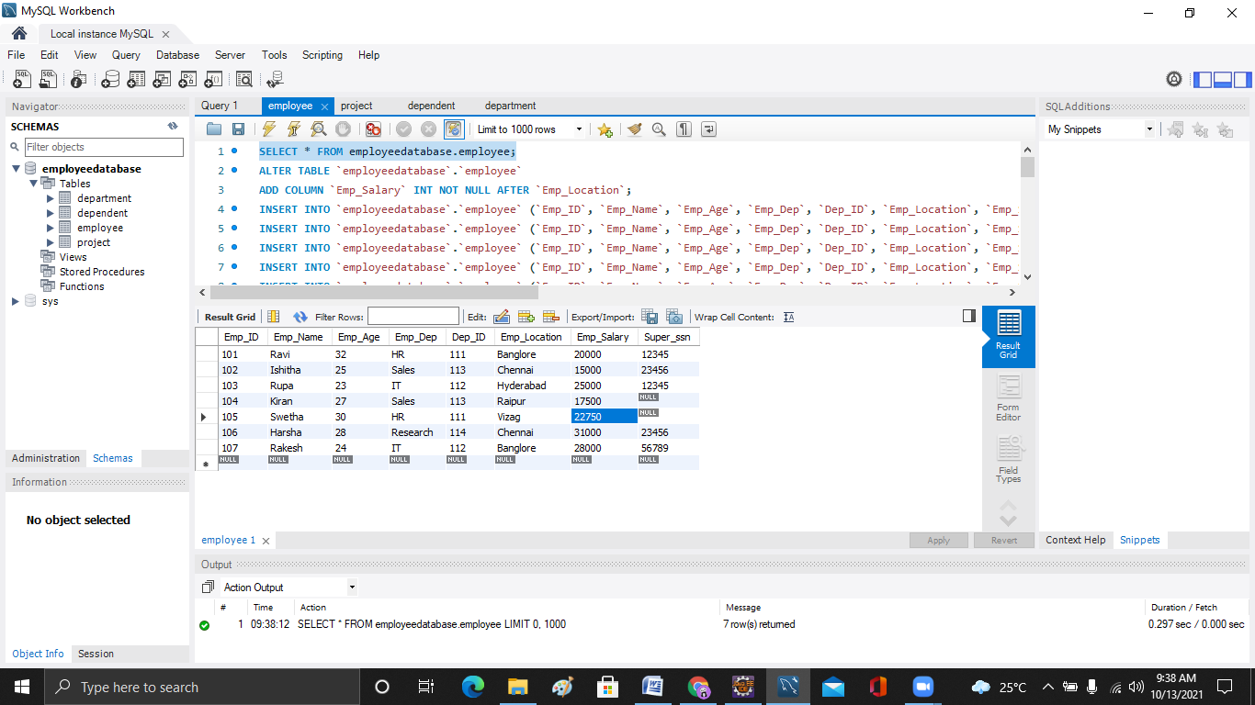

**PROJECT TABLE**

INSERT INTO `employeedatabase`.`project` (`ID_Project`, `Project_Name`, `Project_Location`, `Project_Strength`) VALUES ('11', 'Health_Care', 'Banglore', '5');

INSERT INTO `employeedatabase`.`project` (`ID_Project`, `Project_Name`, `Project_Location`, `Project_Strength`) VALUES ('12', 'EPay', 'Hyderabad', '6');

INSERT INTO `employeedatabase`.`project` (`ID_Project`, `Project_Name`, `Project_Location`, `Project_Strength`) VALUES ('13', 'Stats', 'Chennai', '3');

INSERT INTO `employeedatabase`.`project` (`ID_Project`, `Project_Name`, `Project_Location`, `Project_Strength`) VALUES ('14', 'MLAlgol', 'Banglore', '12');

INSERT INTO `employeedatabase`.`project` (`ID_Project`, `Project_Name`, `Project_Location`, `Project_Strength`) VALUES ('15', 'CSecure', 'Pune', '4');

INSERT INTO `employeedatabase`.`project` (`ID_Project`, `Project_Name`, `Project_Location`, `Project_Strength`) VALUES ('16', 'CCService', 'Chennai', '2');

INSERT INTO `employeedatabase`.`project` (`ID_Project`, `Project_Name`, `Project_Location`, `Project_Strength`) VALUES ('17', 'Basecamp', 'Bhuwaneswar', '20');

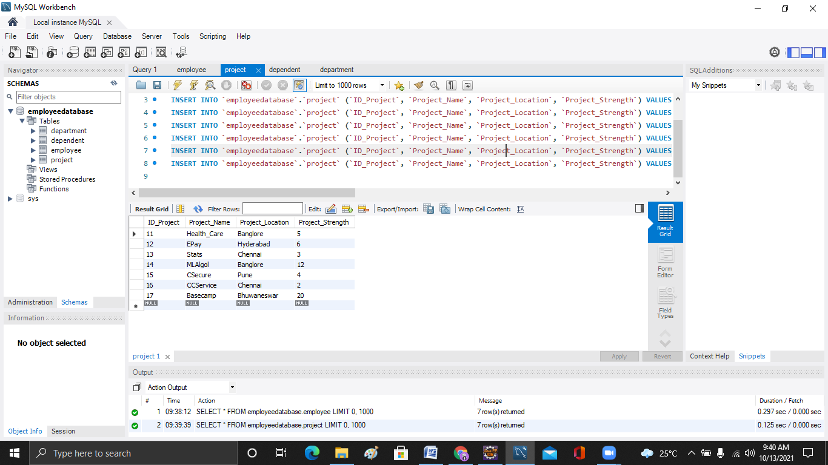

**DEPARTMENT TABLE**

INSERT INTO `employeedatabase`.`department` (`Dep_No`, `Dep_Name`, `Dep_Location`, `Project_ID`) VALUES ('111', 'HR', 'Banglore', '11');

INSERT INTO `employeedatabase`.`department` (`Dep_No`, `Dep_Name`, `Dep_Location`, `Project_ID`) VALUES ('112', 'IT', 'Chennai', '12');

INSERT INTO `employeedatabase`.`department` (`Dep_No`, `Dep_Name`, `Dep_Location`, `Project_ID`) VALUES ('113', 'Sales', 'Pune', '15');

INSERT INTO `employeedatabase`.`department` (`Dep_No`, `Dep_Name`, `Dep_Location`, `Project_ID`) VALUES ('114', 'Research', 'Hyderabad', '13');

INSERT INTO `employeedatabase`.`department` (`Dep_No`, `Dep_Name`, `Dep_Location`, `Project_ID`) VALUES ('115', 'Security', 'Mumbai', '14');

INSERT INTO `employeedatabase`.`department` (`Dep_No`, `Dep_Name`, `Dep_Location`, `Project_ID`) VALUES ('116', 'Learning', 'Bhuwaneswar', '17');

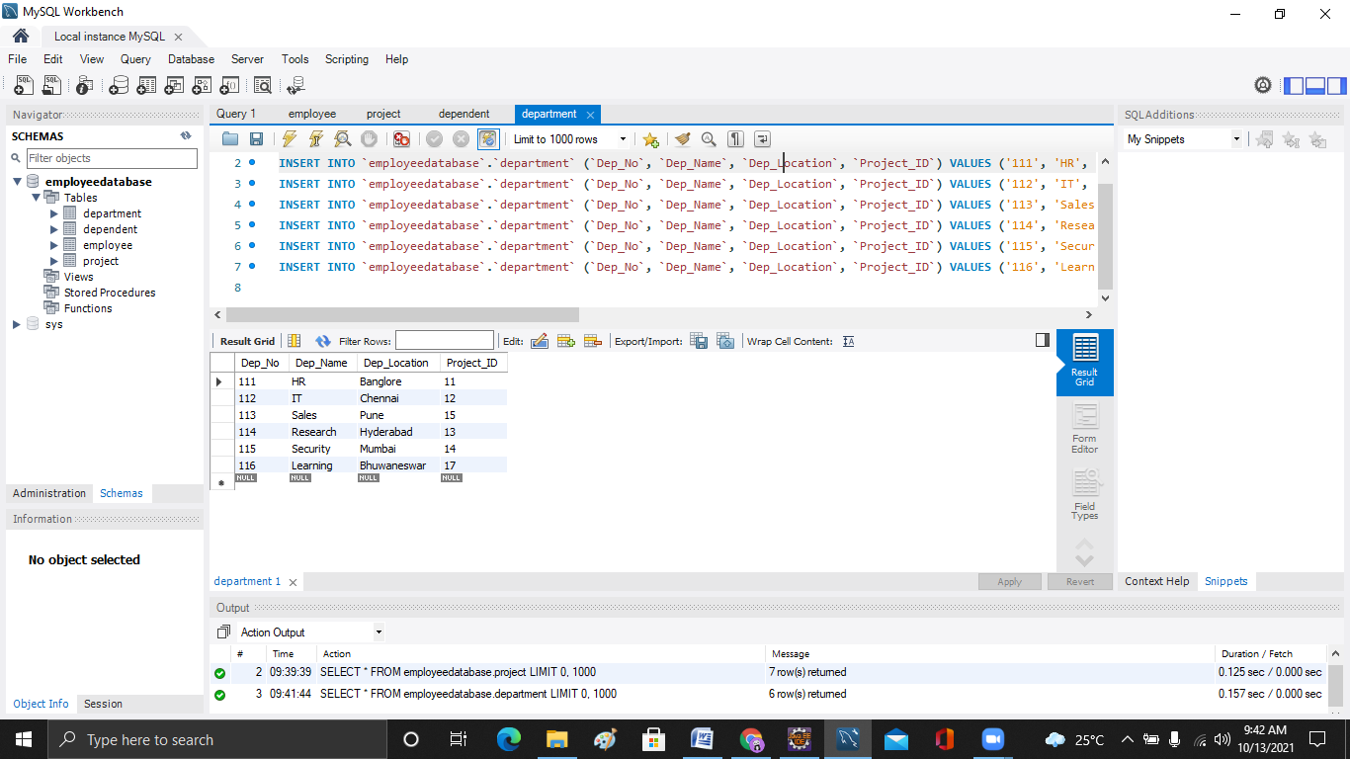

**DEPENDENT TABLE**

INSERT INTO `employeedatabase`.`dependent` (`E_ID`, `Dependent_Name`, `Dependent_Relation`) VALUES ('101', 'Surabhi', 'Wife');

INSERT INTO `employeedatabase`.`dependent` (`E_ID`, `Dependent_Name`, `Dependent_Relation`) VALUES ('102', 'Mahesh', 'Brother');

INSERT INTO `employeedatabase`.`dependent` (`E_ID`, `Dependent_Name`, `Dependent_Relation`) VALUES ('104', 'Rama Rao', 'Father');

INSERT INTO `employeedatabase`.`dependent` (`E_ID`, `Dependent_Name`, `Dependent_Relation`) VALUES ('105', 'Sujitha', 'Mother');

INSERT INTO `employeedatabase`.`dependent` (`E_ID`, `Dependent_Name`, `Dependent_Relation`) VALUES ('106', 'Priya', 'Wife');

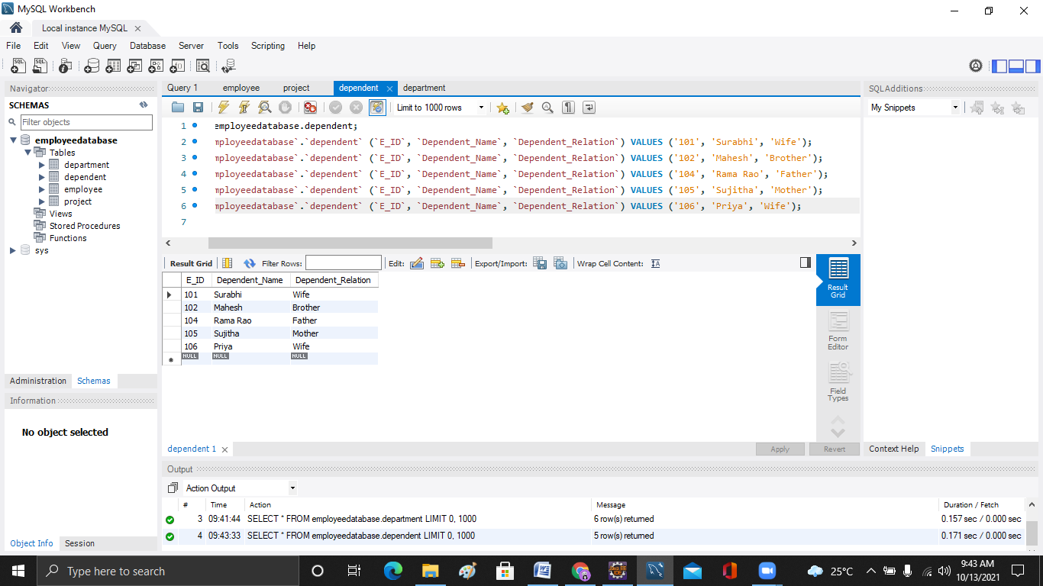

SELECT `Emp_Name`, `Emp_Age`

FROM `employeedatabase`.`employee`

WHERE `Emp_Location`='Chennai';

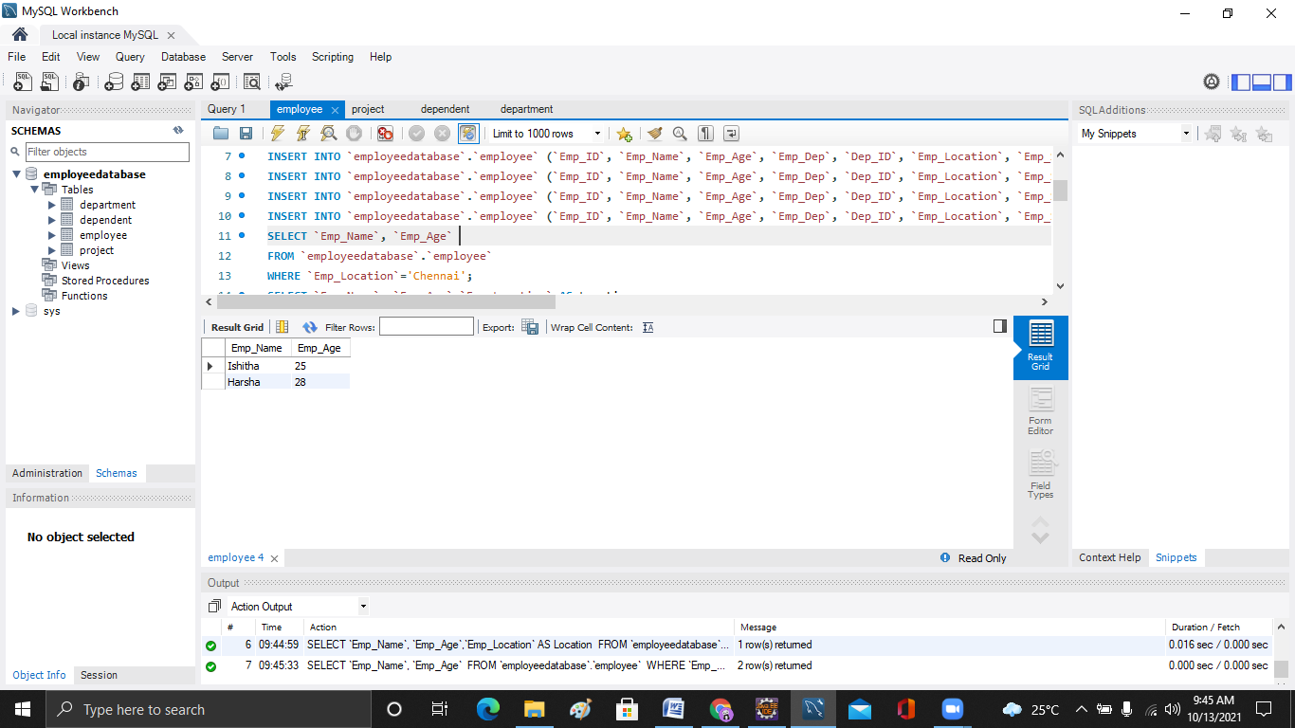

SELECT `Emp_Name`, `Emp_Age`,`Emp_Location` AS Location

FROM `employeedatabase`.`employee`

WHERE `Emp_Dep`='HR' AND `Emp_Salary`>20000;

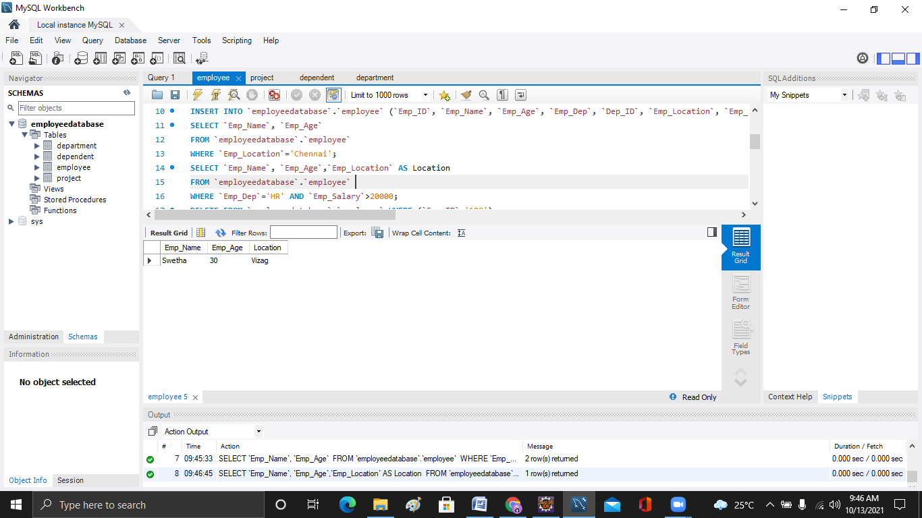

DELETE FROM `employeedatabase`.`employee` WHERE (`Emp_ID`='108');



SELECT avg(`Emp_Salary`)

AS Avg_Salary,Emp_Location

FROM `employeedatabase`.`employee`

GROUP BY `Emp_Location` HAVING Avg_Salary>18000

ORDER BY avg(Emp_Salary) desc;

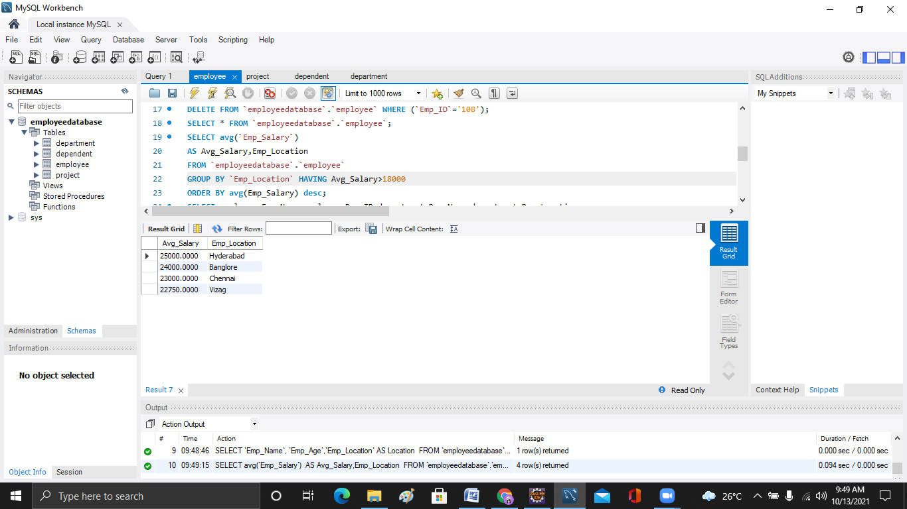

**INNER JOIN**

SELECT employee.Emp_Name,employee.Dep_ID,department.Dep_Name,department.Dep_Location

FROM employeedatabase.employee

INNER JOIN employeedatabase.department

ON employee.Dep_ID=department.Dep_No;

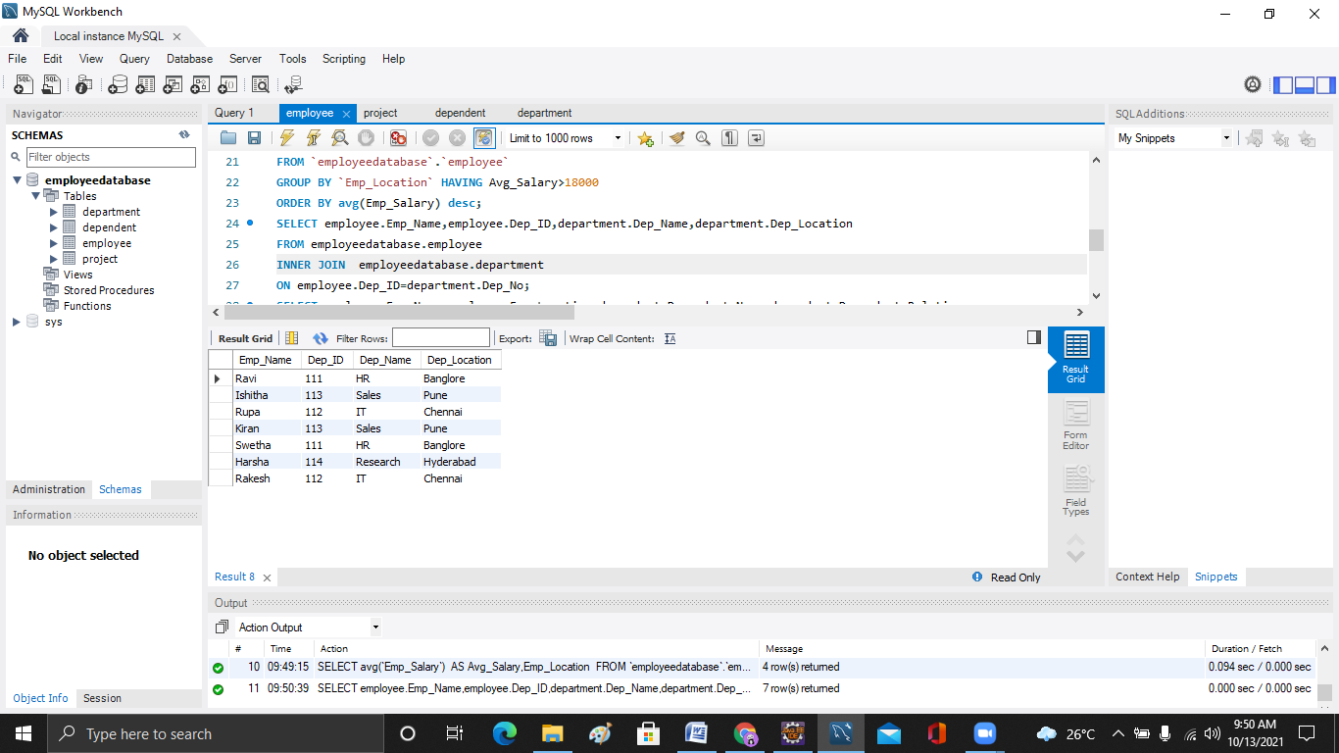

**LEFT JOIN**

SELECT employee.Emp_Name,employee.Emp_Location,dependent.Dependent_Name,dependent.Dependent_Relation

FROM employeedatabase.employee

LEFT JOIN employeedatabase.dependent

ON employee.Emp_ID=dependent.E_ID;

